Design Document for:

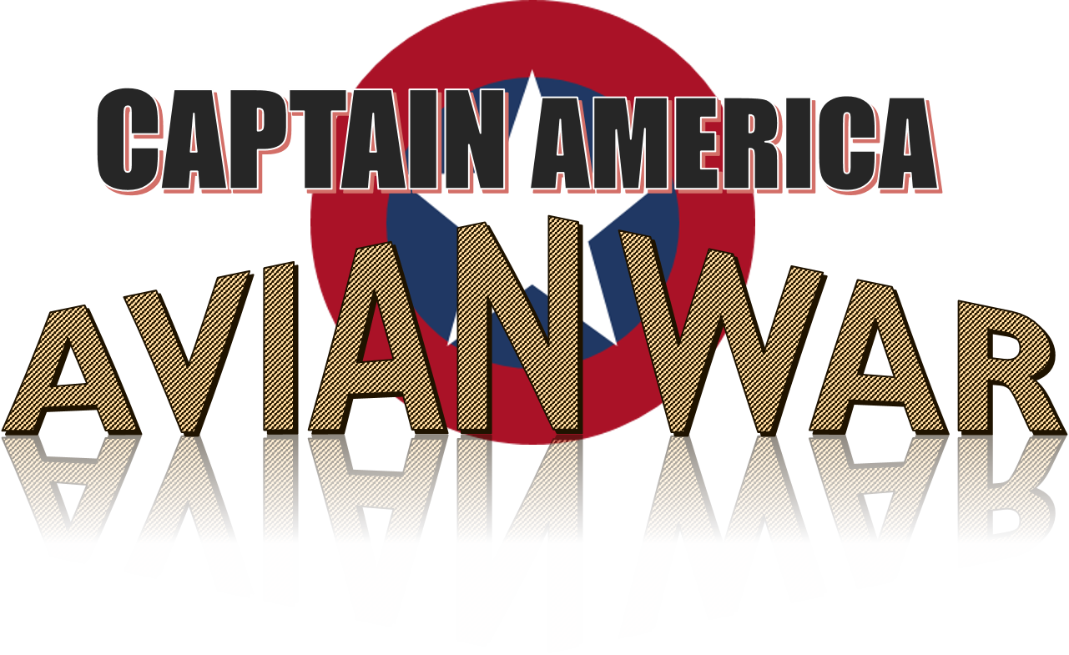

Written by **Jaden Ji Hong Ahn**

Student Number: 7672488

January 5, 2018

Table of Contents

Game Overview 3

Goal of game 3

How to play 3

Featured coding skills 3

Synopsis and Characters 4

Levels 5

Interface 6

Title & Menu 6

Game screen 6

High Score screen 8

Help screen 9

About screen 9

Graphic Resources 10

Sound Resources 10

Class Diagram 11

# Game Overview

Title: Captain America: Avian War

Genre: Action

## Goal of game

Shoot player’s shield to enemies to get high score, without losing it

# How to play

1. Move player character up using arrow up key, or down using arrow down key
2. Shoot the shield using space key
   1. If space key is pressed while moving up, it goes upward right
   2. If space key is pressed while moving down, it goes down right
   3. If space key is pressed while not moving, it goes straight to the right
3. Shield bounces when:
   1. it reaches top, down, or right side of the game screen
   2. it touches enemies
4. You lose a shield when it goes out of the left side of the game screen
   1. It comes back to the player character when it is near the player character
   2. If you lose 3 shields, game is over
5. You score when the shield hit enemies
   1. Enemies have different score
   2. Score is multiplied by number of bounce
   3. Number of bounce increases whenever the shield bounces
   4. Number of bounce is back to 1 when the shield comes back to the player, or it is lost
6. You can get summarized information through in-game help menu

# Featured coding skills

* Various animations
  + Animation for player character, enemies, and explosion effect
  + Parallax scrolling background
    - 5 background layers for stage 1
    - 3 layers for stage 2
* High score system
  + Save, update and load top 5 high scores
  + Input player’s initials with arrow keys
* Game status control
  + Game phase and stage control using enumeration
  + Appropriate game status messages linked with game status
* Various enemy move pattern
  + Various patterns using starting position, starting speed, turn position and turn speed
* Etc.
  + SpriteBatch creating, updating, and drawing, rotating, scaling, moving, changing transparency, managing collision for enemies and a shield
  + Spritefont creating, updating, and drawing
  + Scoring system with wide variations
    - Score = Number of bounces * enemy score

# Synopsis and Characters

* Synopsys: Our Captain has turned himself into a bird to meditate a war among avian. Can he bring peace back to the world?
* Character
  + Player



* + Enemy Basic



* + Enemy Variation 1



* + Enemy Variation 2



# Levels

* Stage 1: Mountain in the daytime



* Stage 2: City at night



# Interface

## Title & Menu

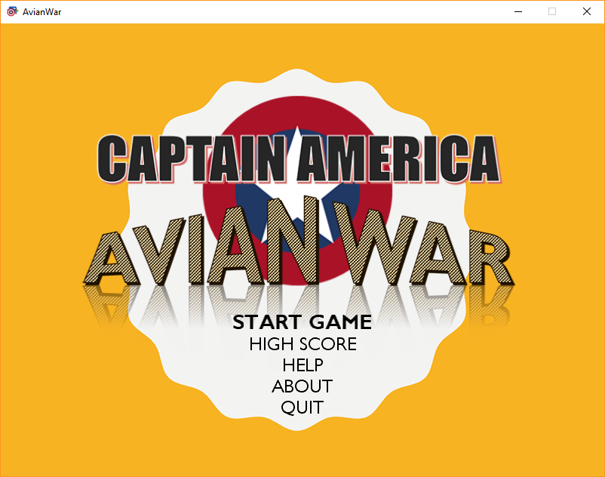

* Use arrow key up or down to navigate through menus

## Game screen

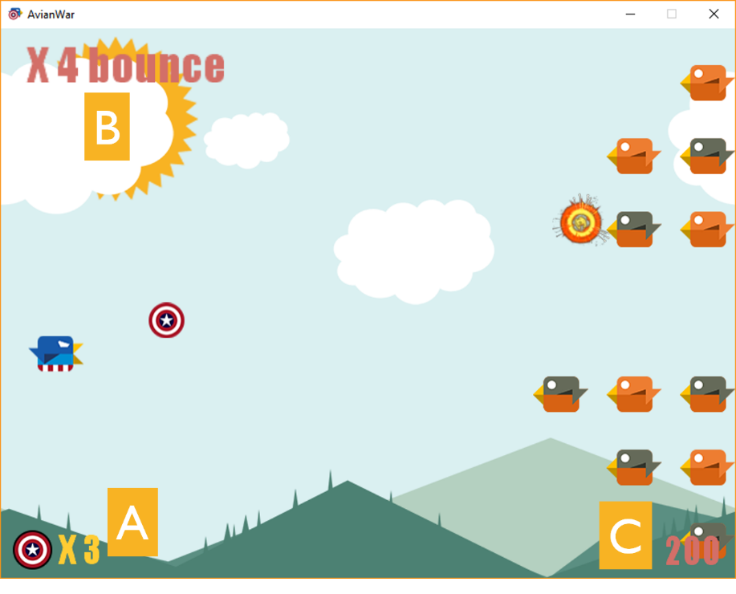

***A****: Number of shields left |* ***B****: Number of bounces |* ***C****: Total score*

* You cannot exit the game while playing
* If you lose all of your shields, game is over

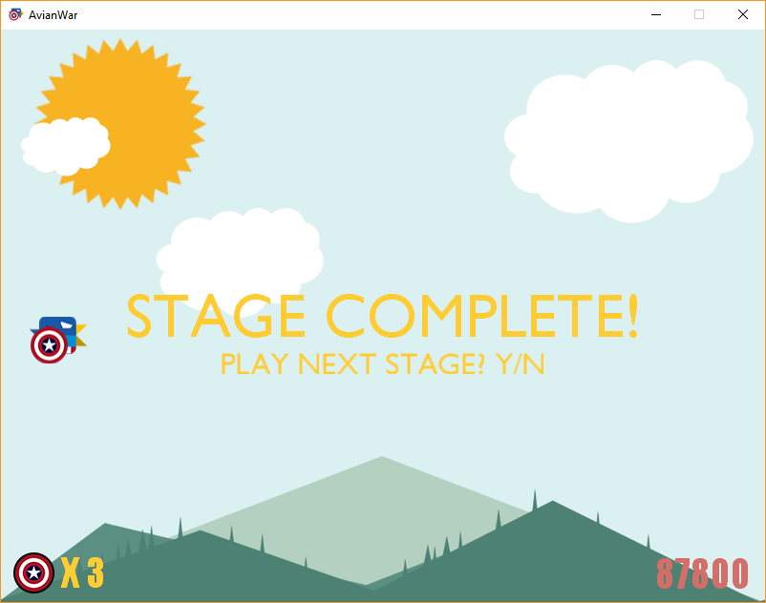

* After stage 1 is over, you can
  + Press Y key to proceed to stage 2
  + Press N key to stop game to make the game over

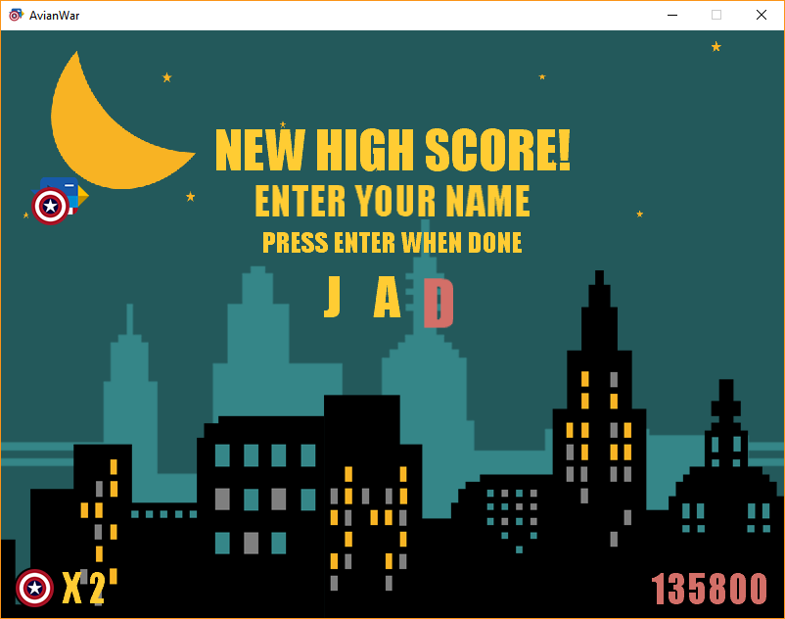

* If you have scored high score, high score input screen is shown
  + You can change letters using arrow up or down key
  + You can change the position of cursor using arrow right or left
  + Press Enter when done, to make the game over

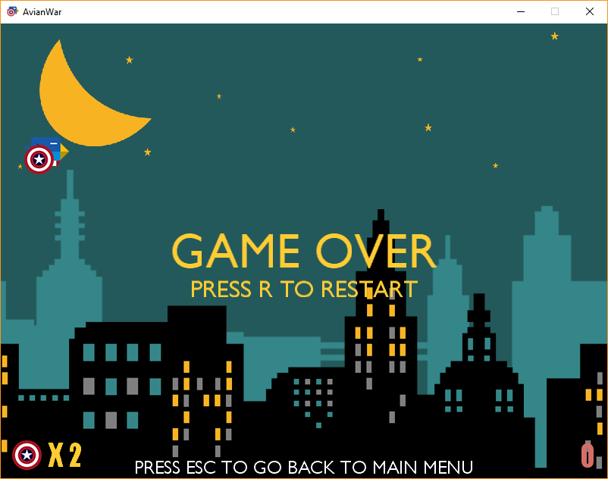

* When a game is over, you can
  + Press R key to restart the game from stage 1
  + Press Esc to go back to the main menu

## High Score screen

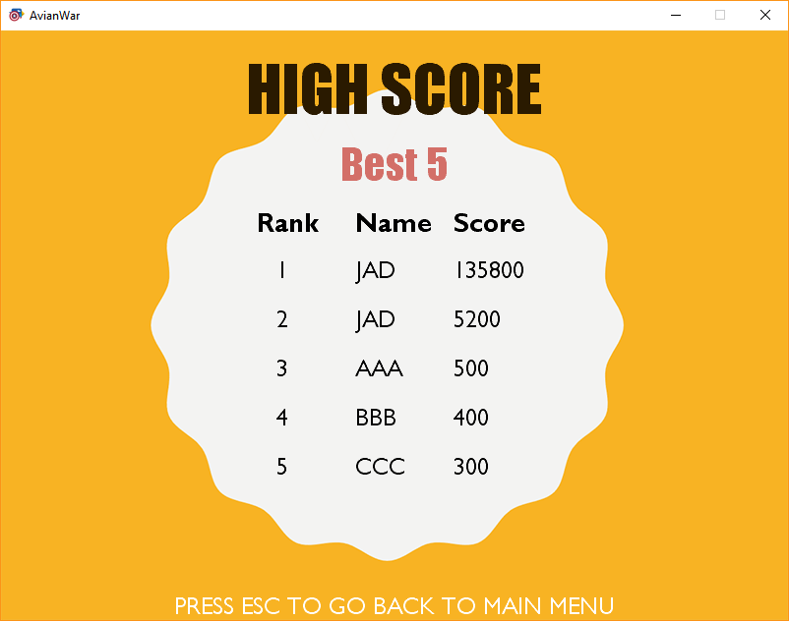

* High score is updated after a game is over
* Press Esc to go back to the main menu

## Help screen

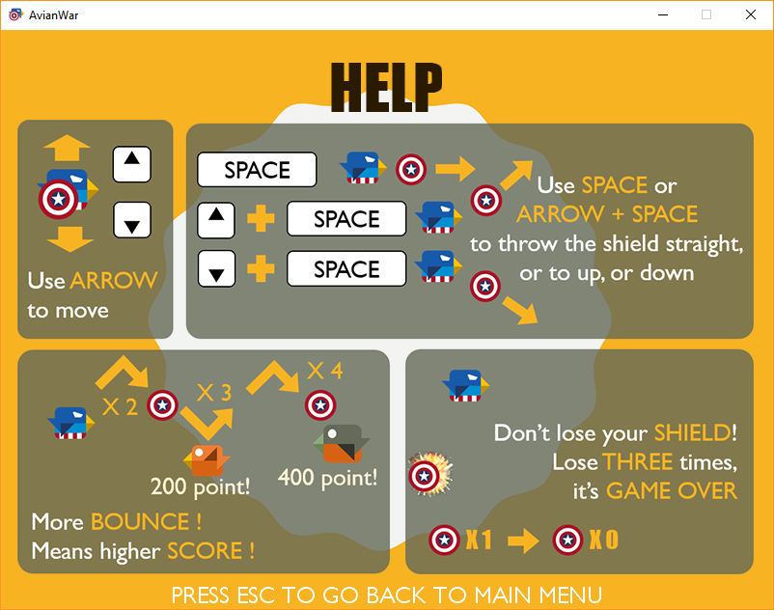

* Press Esc to go back to the main menu

## About screen

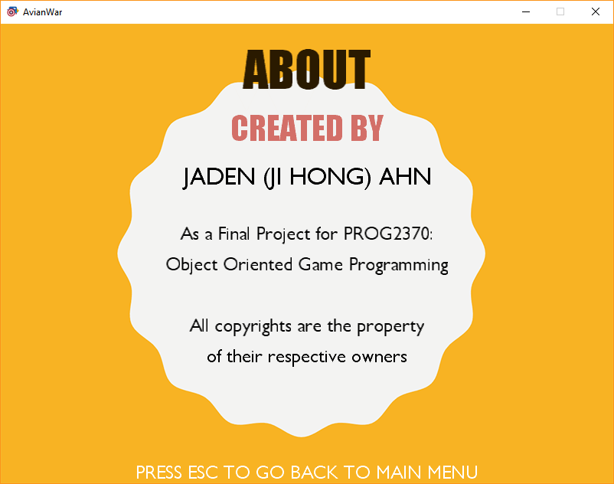

* Press Esc to go back to the main menu

# Graphic Resources

* All the graphic resources including frames in all of the animation and icon image were created by me, using PowerPoint 2017, except for the explosion effect
  + Explosion effect was captured on YouTube and edited
  + Explosion resource origin:
    - *“20 2D explosion animations”* by Александр Терсков
    - <https://www.youtube.com/watch?v=V7Ci54O23XQ>
  + Check attached *GraphicResources.pptx* for more details
* Bird design was referenced from a mobile game, *‘Don’t Touch The Spikes’*
  + <https://play.google.com/store/apps/details?id=com.ketchapp.donttouchthespikes>

# Sound Resources

* All the music is from a video game, ‘*Rayman Legends*’ and ‘*Rayman Origins*’, developed and published by Ubisoft
  + SongGameTitle: Track 16, ‘The adventure begins’ from *Rayman Legends*
  + SongStage1: Track 34, ‘Hi-Ho Moskito (No Kazoo)’ from *Rayman Origins*
  + SongStage2: Track 4, ‘Storming the castle’ from *Rayman Legends*
  + SongGameOver: Track 1, ‘Mysterious swamps’ from *Rayman Legends*
* All the sound effects were downloaded from various sources including:
  + SoundBible.com(<http://soundbible.com>)
  + The Sounds Resource(<https://www.sounds-resource.com>)
  + Most of the sound effects were edited by me, using Sony Vegas

# Class Diagram

